**Institute of Engineering & Technology**

**Devi Ahilya Vishwavidyalaya, Indore (M.P)**

**Department of Computer Science & Engineering**



**DATABASE MANAGEMENT SYSTEM(CER4C4)**

**Lab Assignment-4**

**Submitted To: Submitted By:**

**Mrs. Jyoti Haveliya Mam Tanishq Chauhan (21C4184)**

**CS-Dept CS “B” 2nd Year**

**IET-DAVV**

**Lab Assignment-4**

1. **A company has a number of employees. The attributes of EMPLOYEE include Employee_ID (identifier), Name, Address, and Birthdate. The company also has several projects. Attributes of PROJECT include Project_ID (identifier), Project_Name, and Start_Date. Each employee may be assigned to one or more projects, or employee may not be assigned a project. A project must have at least one employee assigned, and may have any number of assigned .An employee’s billing rate may vary by project, and the company wishes to record the applicable billing rate for each employee when assigned to a particular project.**

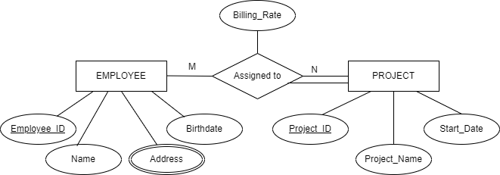

1. **A university has a large number of courses in its catalogue. Attributes of Course include Course_Number, Course_Name and Units. Each course may have one or more different courses as prerequisite, or may have no prerequisite. Similarly a particular course may be prerequisite for any number of courses or may not be prerequisite for any other course.**

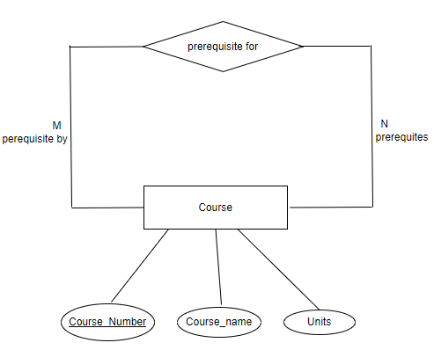

1. **A laboratory has several chemists who work on one or more project. Chemist also may use certain kind of equipment on each project. Attributes of Chemists include Employee_ID, Name and Phone_No. Attributes of Projects include Project_ID and Start_Date. Attributes of Equipment include Serial_No and Cost. The organization wishes to record Assign_Date That is, the date when given equipment was assigned to particular chemist working on a specified project. A chemist must be assigned to at least one project and one equipment item. Given equipment item need not to be assigned, and a given project needs not to be assigned either a chemist or equipment.**

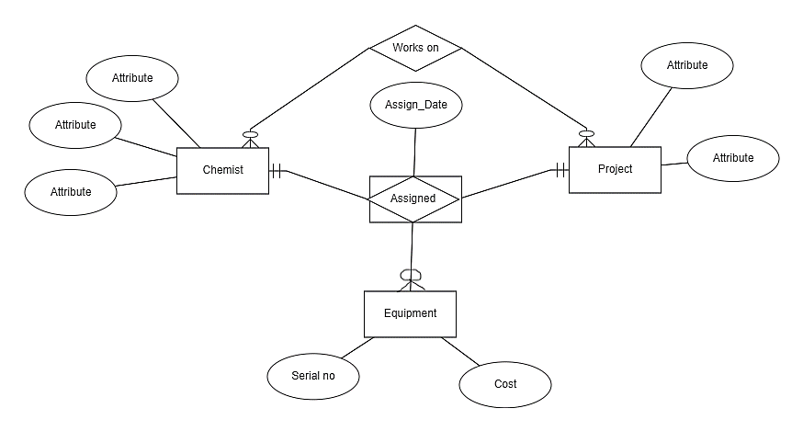

1. **A college course may have one or more scheduled section, or may not have scheduled section. Attribute of course include Course_ID, Course_Name and Units. Attributes of Section includes Section_No and Semester_ID. Semester_ID is composed of two parts: Semester and Years. Section_No is an integer that distinguishes one section from another for same course but does not uniquely identify the section.**

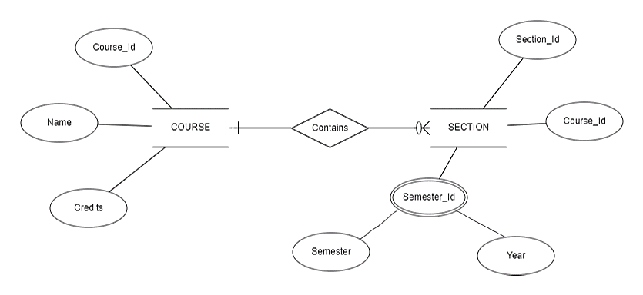

1. **A hospital has large number of registered physician. Attributes of Physician include Physician_ID and Specialty. Patients are admitted to the hospital by physician. Attribute of patient includes Patient_ID and Patient_Name. Any patient who is admitted must have exactly one admitting physician. A physician may optionally admit any number of patients. Once admitted a given patient must be treated by at least one physician. A particular physician may treat any number of patients, or may not treat any patient. Whenever a patient is treated by a physician the hospital wishes to record the details of the treatment. Component of treatment detail include Date, Time and Results.**

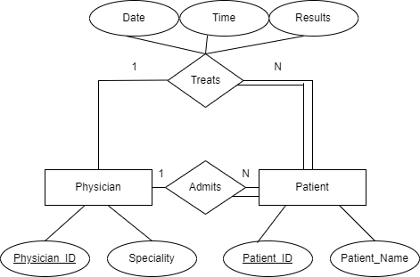

1. **A database is to be designed for a college to monitor students’ progress throughout their course of study. The students are reading for a degree (such as BA, BA(Hons) MSc, etc) within the framework of the modular system. The college provides a number of module, each being characterised by its code , title, credit value, module leader, teaching staff and the department they come from. A module is co-ordinated by a module leader who shares teaching duties with one or more lecturers. A lecturer may teach (and be a module leader for) more than one module. Students are free to choose any module they wish but the following rules must be observed: some modules require pre-requisites modules and some degree programmes have compulsory modules. The database is also to contain some information about students including their numbers, names, addresses, degrees they read for, and their past performance (i.e. modules taken and examination results).**

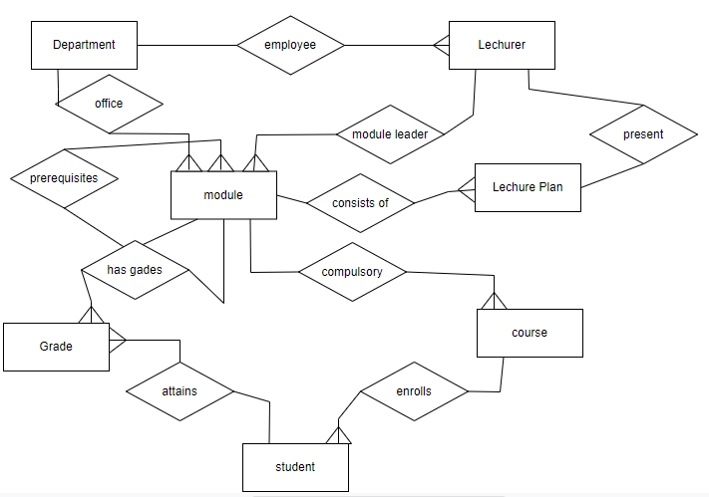

1. **A relational database is to be designed for a medium sized Company dealing with industrial applications of computers. The Company delivers various products to its customers ranging from a single application program through to complete installation of hardware with customized software. The Company employs various experts, consultants and supporting staff. All personnel are employed on long-term basis, i.e. there are no short-term or temporary staffs. A relational database is to be designed for a medium sized Company dealing with industrial applications of computers. The Company delivers various products to its customers ranging from a single application program through to complete installation of hardware with customized software. The Company employs various experts, consultants and supporting staff. All personnel are employed on long-term basis, i.e. there are no short-term or temporary staffs.**

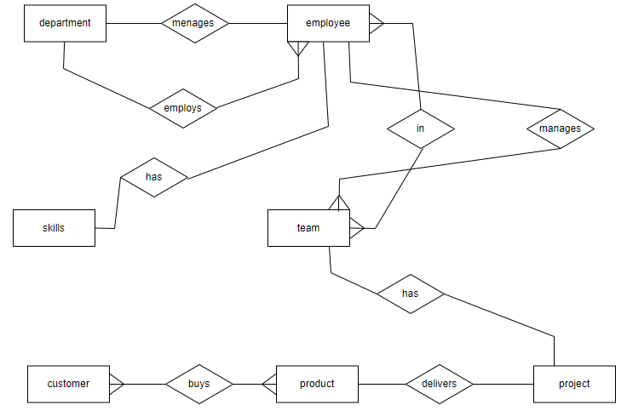

1. **A database is to be designed for a Car Rental Co. (CRC). The information required includes a description of cars, subcontractors (i.e. garages), company expenditures, company revenues and customers. Cars are to be described by such data as: make, model, year of production, engine size, fuel type, number of passengers, registration number, purchase price, purchase date, rent price and insurance details. It is the company policy not to keep any car for a period exceeding one year. All major repairs and maintenance are done by subcontractors (i.e. franchised garages), with whom CRC has long-term agreements. Therefore the data about garages to be kept in the database includes garage names, addressees, range of services and the like. Some garages require payments immediately after a repair has been made; with others CRC has made arrangements for credit facilities. Company expenditures are to be registered for all outgoings connected with purchases, repairs, maintenance, insurance etc. Similarly the cash inflow coming from all sources - car hire, car sales, insurance claims - must be kept of file. CRC maintains a reasonably stable client base. For this privileged category of customers special credit card facilities are provided. These customers may also book in advance a particular car. These reservations can be made for any period of time up to one month. Casual customers must pay a deposit for an estimated time of rental, unless they wish to pay by credit card. All major credit cards care accepted. Personal details (such as name, address, telephone number, driving licence, number) about each customer are kept in the database.**

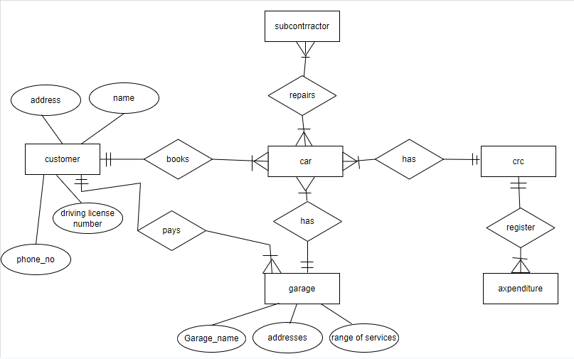

1. **Company expenditures are to be registered for all outgoings connected with purchases, repairs, maintenance, insurance etc. Similarly the cash inflow coming from all sources - car hire, car sales, insurance claims - must be kept of file. CRC maintains a reasonably stable client base. For this privileged category of customers special credit card facilities are provided. These customers may also book in advance a particular car. These reservations can be made for any period of time up to one month. Casual customers must pay a deposit for an estimated time of rental, unless they wish to pay by credit card. All major credit cards care accepted. Personal details (such as name, address, telephone number, driving licence, number) about each customer are kept in the database.**

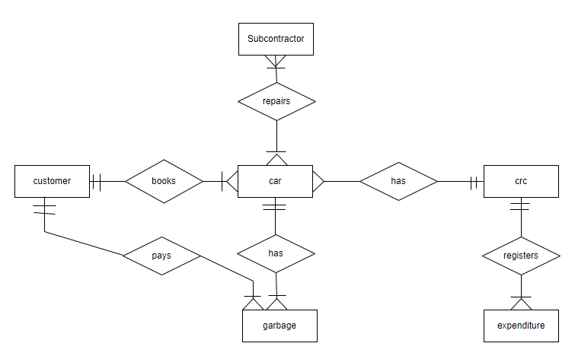

1. **A General Hospital consists of a number of specialized wards (such as Paediatric, Oncology, etc). Each ward hosts a number of patients, who were admitted on the recommendation of their own GP and confirmed by a consultant employed by the Hospital. On admission, the personal details of every patient are recorded. A separate register is to be held to store the information of the tests undertaken and the results of a prescribed treatment. A number of tests may be conducted for each patient. Each patient is assigned to one leading consultant but may be examined by another doctor, if required. Doctors are specialists in some branch of medicine and may be leading consultants for a number of patients, not necessarily from the same ward.**

